ECE2277A Project Report

Name: Isra Elwazir
Student Number: 251132469
Submission Date: Dec 6th2022
Problem Statement
The problem that had to be solved was that given a specific sequence of numbers, that are not in ascending or descending order, the numbers had to be displayed in the sequence found in Table 1. After hitting the last digit, it should be able to reset to the first digit in the sequence. In addition, it should be able to reset from any point in the sequence to the first digit. For example, if number 7 is displayed and then reset is triggered the circuit has to reset to digit 2. The solution to this problem was constructing a sequential circuit (sequential circuits have feedback which means that they have memory) from basic logic elements such as flip-flops, encoders, decoders, multiplexors, or basic logic gates that we learned about in the course.
Sequence | 2 | 7 | 5 | 1 | 4 | 0 | 7
Table 1: The sequence of integers to be displayed in a clocked loop.

Design Method
This problem could have been solved in different ways and using different circuit elements. However, I chose to design it using flip-flops. I designed the circuit using 4 D flip-flops where each flip-flop represents 1-bit. The most significant bit, D3 was used to represent a repeated number in the sequence. Since the sequence has the value of 7 twice then, D3 represents the second 7 that appears in the sequence. It represents it using 15 but in binary which is 1111, Table 2 below shows that. The flip-flops D2, D1, and D0 represent the rest of the unrepeated decimal numbers in the sequence. The current states of the 4 flip-flops, shown in table 2, represent the numbers in the sequence in binary form. The next state is the next number in the sequence. For example, if the current number is 5 then index 5 should represent 1, in binary, as the next state and this 1 will be represented by all the flip-flops, meaning that Q3, Q2, Q1, and Q0 will represent 1 in binary (0001). Each column in the next state represents a flip-flop that the K-maps were made from. From the K-maps, I derived the Boolean expressions that allowed me to simplify the logic I used as the D flip-flop inputs as shown in figure A.
The input for the D flip-flops is equal to the next state which is why in figure A the output is being fed back as the D flip-flop input. Each flip flop is connected to a clock that is used to trigger the transition from one flip-flop to the next. The pre-set and clear inputs are used to define the reset state of the circuit. For my design I let the pre-sets and clears in the flip-flops be represented by the last digit of the sequence so that it resets to the first digit in the sequence, and in Quartus when pre-set, PRN, is equal to 1 and clear, CLR, is equal to 0 then the output will be 0 and when PRN is 1 and CLR is 0 then output will be 0. Since the last digit in my sequence is 7, but it is represented by 15 (1111 in binary) all my flip flops represent 1111 by having their CLR connect to VCC.
The counter is connected to a BCD 7-segment display that is connected to the FPGA board using pins that were already in Quartus. The clock in the main circuit is connected to a key pin. The reset is connected to a switch pin.

Table 2: State table
 | Current State |  |  |  | Next State |  |  |  |  | Input
index | Q₃ | Q₂ | Q₁ | Q₀ | Next | Q₃ | Q₂ | Q₁ | Q₀ | D₄ | D₃ | D₂ | D₁
0 | 0 | 0 | 0 | 0 | 7 (15) | 1 | 1 | 1 | 1 | 1 | 1 | 1 | 1
1 | 0 | 0 | 0 | 1 | 4 | 0 | 1 | 0 | 0 | 0 | 1 | 0 | 0
2 | 0 | 0 | 1 | 0 | 7 | 0 | 1 | 1 | 1 | 0 | 1 | 1 | 1
3 | x | x | x | x | x | x | x | x | x | x | x | x | x
4 | 0 | 1 | 0 | 0 | 0 | 0 | 0 | 0 | 0 | 0 | 0 | 0 | 0
5 | 0 | 1 | 0 | 1 | 1 | 0 | 0 | 0 | 1 | 0 | 0 | 0 | 1
6 | x | x | x | x | x | x | x | x | x | x | x | x | x
7 | 0 | 1 | 1 | 1 | 5 | 0 | 1 | 0 | 1 | 0 | 1 | 0 | 1
8 | x | x | x | x | … | x | x | x | x | x | x | x | x
9 | x | x | x | x | … | x | x | x | x | x | x | x | x
10 | x | x | x | x | … | x | x | x | x | x | x | x | x
11 | x | x | x | x | … | x | x | x | x | x | x | x | x
12 | x | x | x | x | … | x | x | x | x | x | x | x | x
13 | x | x | x | x | … | x | x | x | x | x | x | x | x
14 | x | x | x | x | … | x | x | x | x | x | x | x | x
15 | 1 | 1 | 1 | 1 | 2 | 0 | 0 | 1 | 0 | 0 | 0 | 1 | 0

Q0
 |  | 00 | 01 | 11 | 10
 | 00 | 1 | 0 | x | 1
 | 01 | 0 | 1 | 1 | x
 | 11 | x | x | 0 | x
 | 10 | x | x | x | x

Q1
 |  | 00 | 01 | 11 | 10
 | 00 | 1 | 0 | x | 1
 | 01 | 0 | 0 | 0 | x
 | 11 | x | x | 1 | x
 | 10 | x () | x | x | x ()

Q2
 |  | 00 | 01 | 11 | 10
 | 00 | 1 | 1 | x () | 1()
 | 01 | 0 | 0 | 1 | x
 | 11 | x | x | 0 | x
 | 10 | x | x | x | x ()

Q3
 |  | 00 | 01 | 11 | 10
 | 00 | 1 | 0 | x () | 0
 | 01 | 0 | 0 | 0 | x
 | 11 | x | x | 0 | x
 | 10 | x | x | x | x

Table 3: All the K-maps for each flip-flop
The following Boolean expressions were yielded from the k-maps:
D0= Q2’Q0 + Q3’Q2Q0
D1= Q3 + Q2’Q0’
D2= Q2’ + Q3’Q1
D3= Q0’Q1’Q2’

Implementation
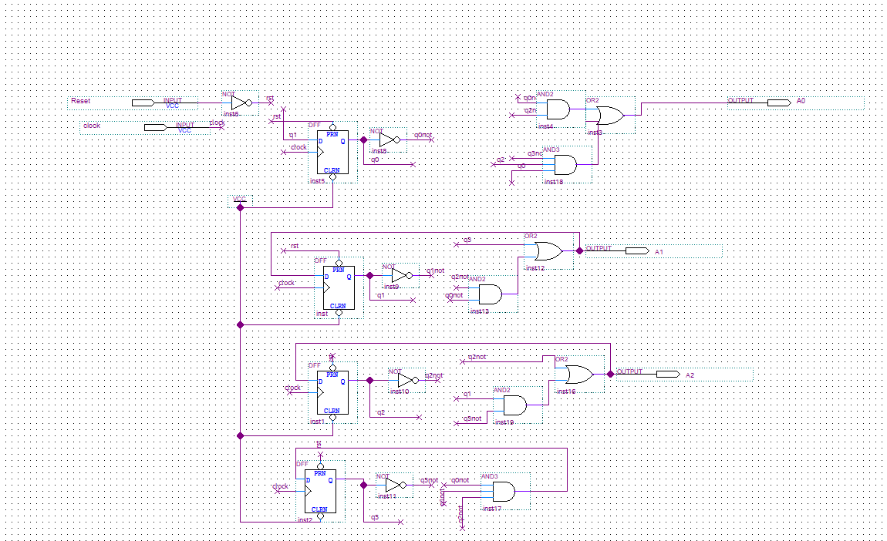
Figure A: (Sequential circuit, D flip-flops)
This is the sequential circuit that has the 4 D flip flops described in detail above. Each flip-flop is connected to a clock. The flip-flops have clear and resets either connected to reset or clear.

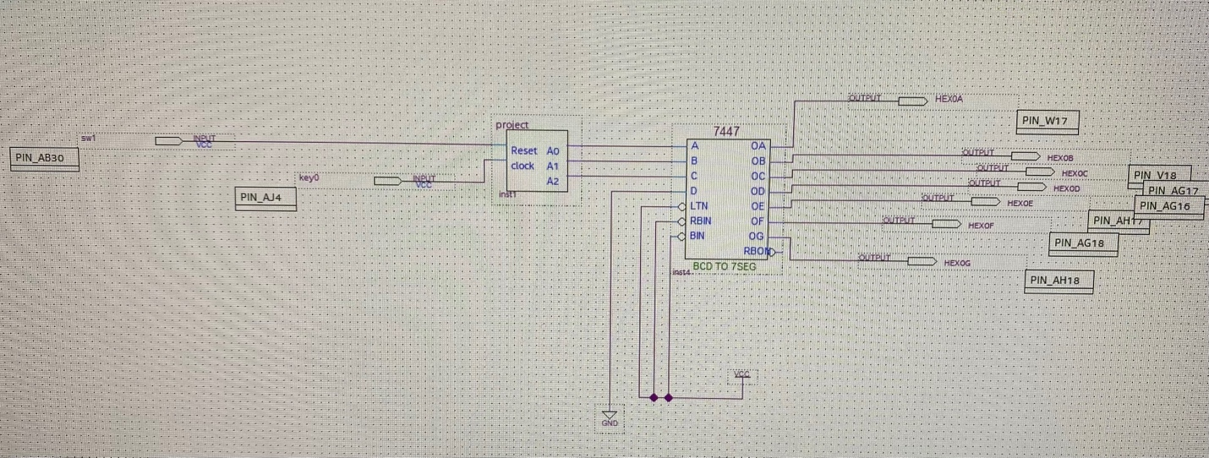
Figure B: The main circuit (The “project” is the Sequence Counter)
The sequence counter outputs the D flip- flop circuit output on the 7-segment display. In Quartus, the most significant bit, C, is connected to A2 in the symbol diagram. The control switch SW0 (sw1) controls the reset and control key KEY0 (key0) controls the clock.

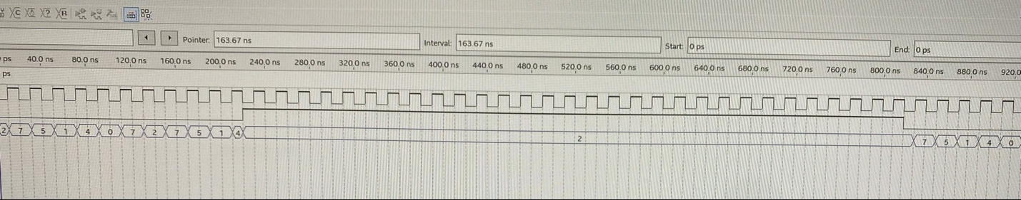
Figure C: The waveform of the sequence (As you can see it resets to the first digit)

Discussion
I chose D flip-flops to minimize the circuit complexity since D flip-flops use the next state as their input, D = Q (t+1), and it also corresponds to the output, so this simplifies Table 2 above which simplifies the K-maps. By using K-maps to derive the Boolean expressions this helped reduce the complexity of the logic outputs by reducing the number of logic gates I needed. Therefore, it helped reduce the overall cost of the circuit. I had two main pins that controlled the circuit, one pin was the clock that was represented by a key pin and this key pin minimizes the design complexity and the overall time it took to implement the circuit because if I hadn’t used a key pin then I would have had to use multiple logic elements to create a clock that would go through the sequence on its own. The second pin I used was the reset pin and that was to reset the sequence to go to the first digit.
Elwazir

